**Non-Linear Programming Models**

**Overview and Rationale**

This assignment is designed to provide you with hands-on experiences to optimize shipments via non-linear programming models in real-life applications. You are provided with a logistics scenario and you are asked to create a model to optimize cost and distribution of shipments. You are also asked to apply the Hodrick-Prescott Filter to a time series stock data.

**Course Outcomes**

This assignment is directly linked to the following key learning outcomes from the course syllabus:

CO1: Use descriptive, Heuristic and prescriptive analysis to drive business strategies and actions

CO4: Incorporate general industry practices in end-to-end analytics development cycles, including data management, data engineering, analytics modeling, optimization, and strategic development

**Assignment Summary**

This assignment consist of two parts. In Part I, you will use R to determine the optimal number of units to be transported from each source to each destination. In Part II, you will apply the *Hodrick-Prescott Filter* to a time series problem.

**Part I: Transshipment Problem**

This part of the capstone project is to be entirely completed in a separate Excel workbook. After completing part 1, please save your workbook as:

ALY6050-Capstone-Part1-Last Name-First Initial.xlsx, and submit it as an attachment. There is no need to include a Word document for this portion of the project.

The following network describes a transshipment scenario in which there are four sources A, B, C, and D, there are four destinations P, Q, and R, and S, and there are three intermediary distribution centers X, Y, and Z as shown. Each line segment indicates an existing shipping route, and the value next to each line segment represents the cost of shipping for one unit of an item from the source on the left of that line to the destination on the right of it. Furthermore, each of the three intermediary distribution facilities X, Y, and Z can handle only up to 50,000 units to be loaded/unloaded at that facility. The sources’ supplies capacities and the destinations’ demands are given in the following table.

|  |  |  |  |
| --- | --- | --- | --- |
| **Sources** | **Supplies** | **Destinations** | **Demands** |
| A | 32,500 | P | 22,500 |
| B | 41,200 | Q | 35,000 |
| C | 18,000 | R | 39,700 |
| D | 22,500 | S | 16,800 |

Set up this transshipment problem R to determine the optimal number of units to be transported from each source to each destination. Use the LpsolverAPI in R to solve the problem. Highlight the optimal transportation cost in your report.

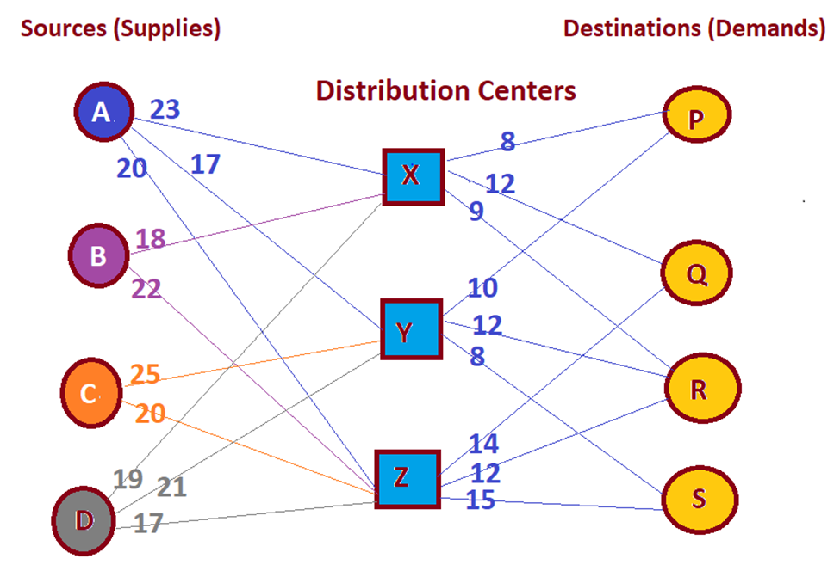

**Part II: Applications of Quadratic Programming**

The Hodrick-Prescott Filter (Decomposition) is a mathematical method used in real business cycle theory in economics to decompose a time series into its cyclical and trend components. Its formulation is based on the following quadratic programming problem: Let $X_{t}$ be the logarithm of a time series (hence, itself a time series). The Hodrick-Prescott filtering decomposes $X_{t}$ into its cyclic component $C_{t}$ and its trend component $T_{t}$ (that is, $X_{t}=C_{t}+T_{t}$) such that the following quadratic objective functional is minimized:

$$Z=\sum_{t = 1}^{N}{{C_{t}}^{2}}+ ω \sum_{t = 2}^{N-1}{{\left(T_{t+1}-2 T_{t}+ T_{t-1}\right)}^{2}}$$

As for the multiplier $ω$, Hodrick and Prescott recommend $ω=100$ for an annual time series, $ω=1600$ for a quarterly time series, and $ω=14400$ for a monthly time series.

1. Perform a research about the Hodrick-Prescott decomposition and provide insights about its historical development.
2. Interpret each term of the Hodrick-Prescott objective function, and discuss a few advantages and disadvantages of this decomposition method.
3. Consider the quarterly time series of Honeywell (HON) stock prices (courtesy of <https://finance.yahoo.com> given in the Excel workbook: *Week 6 Project-part 2-Data.xlsx*. Apply the Hodrick-Prescott optimization method to decompose the logarithm of the given time series into its cyclic and trend components. Use R to solve the problem.
4. Interpret the results obtained from step 3, above, and discuss the merits of your decomposition, in Word; if any.
5. Plot the line plots of the original time series along with its trend component on the same chart.
6. Use the results of your decomposition method and write a summary conclusion of your findings in Word.

**Hint:** Note that the Hodrick-Prescott decomposition of the logarithm of a time series is an additive decomposition; thus this decomposition becomes a multiplicative type of decomposition for the original time series. In other words, if *y* is the original time series and if $x=log(y)$, then the decomposition $x=c+t$ for *x* implies that $y={10}^{ c+t}=({10}^{c})({10}^{t})$.

**Format & Guidelines**

Submissions should consist of an R file and a Word document. The report should follow the following format:

1. Introduction
2. Analysis
3. Conclusion

And be 1000 - 1200 words in length, not including the title page, and presented in the APA format.

**Rubric**

| **Category** | **Exceeds Standard** | **Meets Standards** | **Approaching Standards** | **Below Standards** |
| --- | --- | --- | --- | --- |
| **R: Problem Modeling & Set-up**  ALY6050-CO1 | Completely and concisely modeled the problem in Excel (or R) for each method | Accurately modeled the problem in Excel (or R) for each method | Correctly modeled the problem in Excel (or R) for each method, but the model lacks detailed insight into the problem or the set-up is awkward. | Modeled the problem in Excel (or R) for each method, but there are some gaps in the problem modeling and setup |
| **R: Problem Solution & Accuracy**  ALY6050-CO1 ALY6050-CO4 | Efficiently obtained correct and accurate solutions in Excel (or R) by using the appropriate analytic tools of the software | Obtained complete and accurate solutions in Excel (or R) by using the appropriate analytic tools of the software | Obtained correct solutions in Excel (or R) using the appropriate analytic tools of the software, but the application of the tool is awkward. | Obtained a solutions in Excel (or R) by using the appropriate analytic tools of the software, but the solution is not complete. |
| **Word/Report: Problem Description & Introduction**  ALY6050-CO4 | Provides a thorough and concise summary of the problem descriptions and introduced the problem using rich and significant ideas | Provides an accurate and succinct summary of the problem descriptions and problem introduction | Provides an accurate summary of the problem descriptions and problem introduction, but the description is too wordy or not succinct | Provided a summary of the problem descriptions and problem introduction, but it is inaccurate or incomplete |
| **Word/Report: Description of Problem Analysis**  ALY6050-CO4 | Provides a thorough and precise description of the analytic concepts and theories used in analyzing the problem | Accurately describes the analytic concepts and theories used in analyzing the problem | Describes the analytic concepts and theories used in analyzing the problem, but description lacks appropriate detail or precision | Describes the analytical concepts and theories used in analyzing the problem, but descriptions are incorrect or the analytical concepts and theories are incorrect |
| **Word/Report: Description of Conclusions**  ALY6050-CO4 | Provides conclusions and results obtained in the project using a high level of critical thinking and reasoning | Provides relevant conclusions and results obtained in the project that reflect critical thinking and reasoning | Provides conclusions and results obtained in the project, but not all conclusions or results are relevant to the problem or not all conclusions reflect good reasoning | Provides conclusions and results obtained in the project, but they are irrelevant and reflect a lack of critical thinking |
| **Word/Report: Writing Mechanics, Title Page, & References** | Completely free of errors in grammar, spelling, and punctuation; and completely correct usage of title page, citations, and references. The report contains a minimum of 1000 words | There are no noticeable errors in grammar, spelling, and punctuation; and completely correct usage of title page, citations, and references. The report contains a minimum of 1000 words | There are very few errors in grammar, spelling, and punctuation; and completely correct usage of title page, citations, and references. The report contains a minimum of 1000 words | There are more than five errors in grammar, spelling, and punctuation; or the usage of title page, citations, and references are incomplete; or the report contains less than 1000 words |